**Designing an Identifier System to Enhance ASCII Art Recognition in LLMs**

David Hua

Department of Computer Science, The University of British Columbia

August 31, 2025

**Abstract**

ASCII art presents a unique challenge for Large Language Models (LLMs) due to its nature of encoding visual patterns using textual characters. This can allow inappropriate or harmful content to bypass moderation systems. To address this vulnerability, a generalizable identifier system that operates at inference time to improve ASCII art recognition in LLMs is designed. The system converts ASCII art into an image and passes it to a Vision-Language Model (VLM) for recognition. By doing so, the approach improves recognition of ASCII-encoded content without requiring any retraining of LLMs. This approach is evaluated using a custom dataset of ASCII art examples collected online, comparing baseline and enhanced model responses based on feature coverage, hallucination rates, and improper detection rate. Results show that this lightweight VLM-based pipeline significantly improves ASCII interpretation and detection of harmful or offensive elements. This system offers a practical step toward safer AI applications, especially in content moderation and platform safety.

*Keywords*: large language models, visual language models, ASCII art, content moderation, offensive detection

***Warning: this paper contains examples of toxic language used for research purposes.***

**Generalizable Identifier System for Enhancing ASCII Art Recognition in LLMs**

Large Language Models (LLMs) such as ChatGPT (OpenAI, 2025), Claude (Anthropic, 2025), and Gemini (Google, 2025) have demonstrated impressive capabilities in processing text-based information, but they often struggle with interpreting non-standard formats such as ASCII art: "the art of creating images using text characters as their constituent elements" (O'Grady & Rickard, 2008). This limitation can result in serious consequences when harmful messages are conveyed in the form of ASCII art. In online media, ASCII art can be used to bypass content moderation systems, leading to harassment, hate speech, rumour, or cyberbullying that can not be easily detected by current text-only LLM filters.

This study was motivated by the growing concern that current LLMs fail to grasp the visual nature of ASCII art and may misinterpret or overlook offensive content embedded in it. By enhancing LLMs’ ability to recognize ASCII art, this research aims to support safer online communication and strengthen the AI tools available for digital content moderation.

To address this gap, a generalizable identifier system is built to convert ASCII art into an image and pass it to a Vision-Language Model (VLM) for interpretation. This pipeline operates at inference time and does not require any retraining of the LLMs, making it practical and low-cost.

The key research question is: How does routing ASCII art through a VLM affect LLMs’ ability to recognize and flag harmful content compared to processing ASCII as plain text? This question forms the foundation for the methodology and evaluation approach.

Ultimately, this research contributes to both the technical improvement of LLM-VLM integration and the effect of protecting internet users from online abuse.

**Literature Review**

Large Language models (LLMs) have developed rapidly in recent years. Recent models, such as GPT-4 (OpenAI, 2023), Claude Sonnet 4 (Anthropic, 2025), and Gemini 2.5 Flash (Google, 2025), demonstrate pioneering performance on tasks like image generation and software code analysis (Ortiz, 2024), making them powerful tools in both academic and professional settings.

One emerging area of LLM development involves multimodal content recognition, where researchers explore how LLMs can process and integrate information across different modalities. For instance, Chandraumakantham et al. (2024) demonstrate that combining LLMs with visual features through feature fusion improves emotion recognition accuracy. Similarly, Wu et al. (2024)’s work shows that LLMs can perform competitive image classification when provided with structured textual input, highlighting their potential capacity for visual reasoning. In financial field, Lu et al. (2025) show how LLMs with domain adaption can effectively handle complex entity recognition tasks. Besides, Sah et al. (2024) apply multimodal LLMs to autonomous driving systems, which achieve robust performance in tasks like traffic sign recognition and detection by combining visual inputs and semantic understanding.

Despite this progress, LLMs still face challenges. Particularly, they struggle in tasks that require visual–textual alignment in non-traditional formats and fail to recognize the visual patterns in ASCII art (Wang et al., 2025). Multiple models were benchmarked on curated ASCII datasets, reporting average performance near 30%, well below human levels (Jia et al., 2024). Concurrently, Bayani (2024) tested ChatGPT (GPT-3.5) on cross-modal tasks involving ASCII art and found that GPT-3.5 handles trivial cases but struggles with anything abstract or complex, indicating that transformer LLMs have some latent visual understanding of ASCII art, but far from human-level. Besides, numerous studies illustrate that current LLMs lack robust inference-time mechanisms to interpret ASCII art, as their token-by-token reading fails to assemble the visual meaning, especially when the ASCII is built with positive words (Alon & Kamfonas, 2023; Berezin et al., 2024; Jiang et al., 2024).

Despite acknowledging these threats, existing literature does not explore dynamic rerouting strategies using VLMs. Without such mechanisms, harmful ASCII content can bypass detection in real-world AI moderation systems, allowing harassment or hate speech to persist on online media. This study addresses the gap by testing an identifier system that can more effectively detect hidden offensive ASCII content, ultimately enhancing online user protection.

**Methodology**

A custom dataset (see Appendix B for sample data) was constructed by collecting ASCII art examples from public sources manually, including ASCII art websites (Emoticons, n.d.; **ASCII-Emoticons, n.d.**), Reddit (PIXELPLANETZ, 2025), and Wikipedia ("List of emoticons", 2025). Each entry includes a unique ID, ASCII content, type (either kaomoji or multiline), and a binary offensive label (1 for offensive, 0 for benign). Offensive labeling was manually annotated, with an emphasis on visual interpretation and sociocultural context. This dataset aimed to reflect a diverse spectrum of ASCII content, including kaomojis and complex multiline ASCII art. Reddit samples were chosen to represent ASCII content commonly encountered by users in real-world social media, while online ASCII repositories reflect the typical sources used for creating or searching ASCII art. Together, these sources cover a broad range of ASCII formats that online media platforms may need to detect and interpret.

Three state-of-the-art LLMs were selected from three major AI developers: GPT-4o (OpenAI, 2025), Claude Sonnet 4 (Anthropic, 2025), and Gemini 2.5 Flash (Google, 2025). They were selected for their capability of processing both text and image inputs. DeepSeek was initially considered but excluded because it did not support multimodal input, a core requirement for this study.

These models were then prompted to interpret the ASCII text (see Appendix D for the prompts). Their responses were evaluated by GPT-4.1 (OpenAI, 2025) using three scoring metrics: coverage (1 if all expected features were correctly identified, 0 otherwise), hallucination (1 if any features were falsely identified, 0 if none), and improper detection (1 if improper or offensive elements were identified, 0 if not). GPT-4.1 was selected instead of human raters to ensure consistent application of evaluation criteria and eliminate subjective bias. The process will be repeated with ASCII Arts being converted into images for visual interpretation, and scores will be saved in XLSX files (see Appendix C for sample results).

Quantitative analysis was conducted using Python (Jupyter Notebook). Exploratory data analysis was first performed to summarize model-wise performance on each metric. Improper detection was further evaluated for both text and image inputs using standard classification metrics: accuracy, precision, recall, and F1-score. Additional subgroup analysis was performed to evaluate differences in recognition performance (coverage, hallucination, and improper detection) across benign versus offensive ASCII and kaomoji versus multiline structures. Then, paired t-tests and Wilcoxon signed-rank tests were conducted to compare recognition performance between input modes across all three models. To quantify the magnitude and precision of improvement, mean score changes were computed along with their 90% confidence intervals. This represents the range that would contain the true effect in 90% of cases if the experiment were repeated many times under the same conditions. Finally, the statistics were visualized using Matplotlib to provide clearer interpretation and presentation.

Analyses progressed from description to inference. EDA with standard classification metrics and subgroup comparisons established baseline patterns and differences by ASCII type and offensiveness. Changes from text to image input were then tested using a paired t-test and, for robustness to non-normality (i.e., when differences are not normally distributed), the Wilcoxon signed-rank test. 90% confidence intervals for the improvement of recognition performance complemented those tests. Final visualizations integrated results and highlighted comparative patterns for interpretation.

**Findings**

This study focuses on evaluating whether a generalizable identifier system can improve the ability of large language models (LLMs) to recognize and moderate ASCII-based content.

The main hypothesis was that converting ASCII text into image input would increase recognition accuracy and reduce hallucination (false positives), especially in the case of complex or offensive ASCII art. Findings from multiple statistical analyses strongly support this claim.

Exploratory data analysis showed that recognition performance varies significantly by content type and input mode. For simple ASCII art (kaomoji), all three models achieved nearly perfect recognition (accuracy rate = 0.95) and minimal hallucination (hallucination rate = 0.05) even with text input. Rerouting made no significant improvement, confirming that visual rerouting is unnecessary for kaomojis.

In contrast, multiline ASCII art revealed major limitations in text-based recognition. Accuracy was low (accuracy rate = 0.12) and hallucination was high (hallucination rate = 0.88) across models. After converting to image input, the recognition rate improved to 0.81, and hallucination fell to 0.14. This demonstrates the identifier system's effectiveness in supporting visual-text alignment in complex formats.

As is depicted in Figure 1, subgroup analysis further highlighted that the system benefited offensive ASCII samples most. Recognition accuracy for offensive content increased from 0.46 to 0.79, while hallucination decreased from 0.54 to 0.17. For non-offensive contents, image input still improved performance (accuracy: 0.78 → 0.92; hallucination: 0.22 → 0.06), though the gains were less significant. These results indicate that the system is particularly effective for offensive ASCII art, while still providing moderate benefits for non-offensive content.

**Figure 1**

*Model Performance on ASCII Art Recognition*

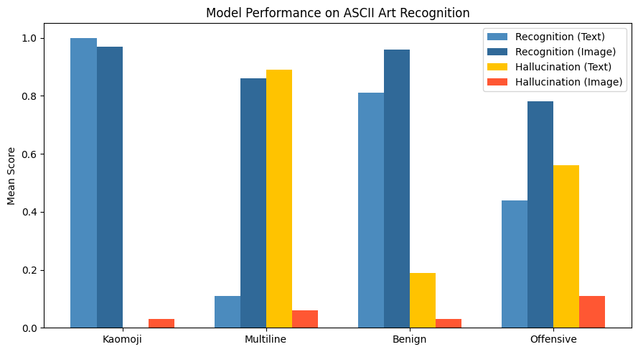

Improper detection performance was evaluated using standard metrics. The results (Table 1, Table 2 and Figure 2) show clear improvements in detection performance after rerouting ASCII art through image input. With text input, GPT-4o and Claude-Sonnet-4 both had F1-scores of 0.67, while Gemini-2.5-Flash reached 0.55. After rerouting, GPT-4o and Gemini improved to 0.93 and 0.67, and Claude-Sonnet-4 achieved perfect detection (F1 = 1.00). Precision was consistently high across all settings, but recall significantly improved with image input, especially for GPT-4o (0.50 → 0.88) and Claude (0.50 → 1.00). These results suggest that image input helps models better recognize visual patterns and reduces their tendency to overlook inappropriate content embedded in ASCII art.

**Table 1**

*Detection performance of LLMs on improper ASCII content using text input*

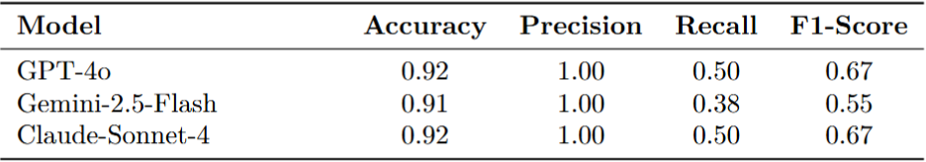

*Note*. This table presents the detection performance of LLMs on improper ASCII content using text input, reported as Accuracy, Precision, Recall, and F1-score. Accuracy measures the proportion of total predictions that are correct. Precision reflects the proportion of predicted improper ASCII samples that are actually improper (i.e., it penalizes false positives). Recall quantifies the proportion of actual improper ASCII samples correctly identified (i.e., it penalizes false negatives). F1-score is the harmonic mean of precision and recall, calculated by formular $F_{1} Score=2 × \frac{Precision ×Recall}{Precision+Recall}$. It offeres a balanced measure when both false positives and false negatives matter. Higher values of F1 indicate the model is both accurate and comprehensive in detecting offensive content.

**Table 2**

*Detection performance of LLMs on improper ASCII content using image input*

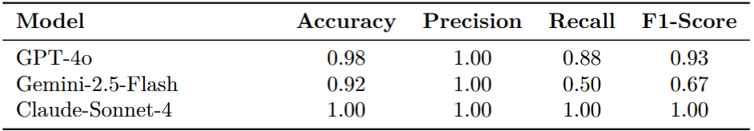

*Note*. This table presents the detection performance of LLMs on improper ASCII content using image input. Metrics are defined as in Table 1.

**Figure 2**

*Offensive ASCII Detection F1-Score by Model*

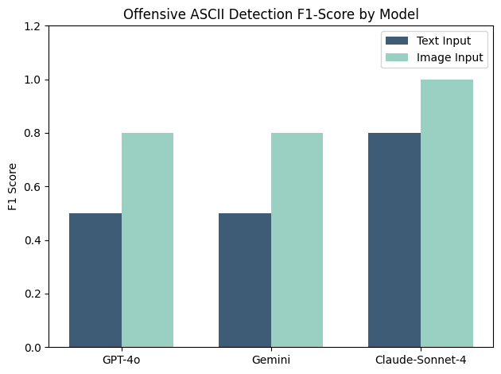

To evaluate the statistical significance of these gains, paired t-tests and Wilcoxon signed-rank tests were applied to recognition scores across input modes (Table 3). Results confirmed significant improvements for GPT-4o and Claude-Sonnet-4 (p < 0.05), and marginal significance for Gemini-2.5-Flash (p ≈ 0.07), using a 90% confidence level. These tests validated that improvements were not due to random variation.

**Table 3**

*Statistical significance of recognition accuracy improvement after image-based rerouting, evaluated by both paired t-test and Wilcoxon signed-rank test*

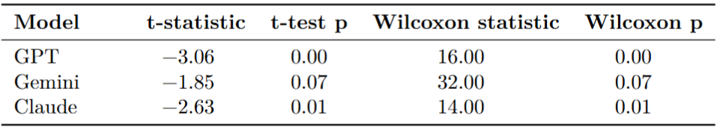

Finally, bootstrap resampling (Figure 3) was used to estimate the average magnitude and uncertainty of improvement. Mean recognition gains ranged from +0.13 (Gemini) to +0.21 (GPT-4o), with 90% confidence intervals excluding zero for all models. These intervals (e.g., GPT-4o: [0.094, 0.321]) demonstrate that the observed improvements are statistically credible and generalizable.

**Figure 3**

*Boostrap Distrubution of GPT4o, Claude-Sonnet-4 and Gemeni-2.5-Flash*

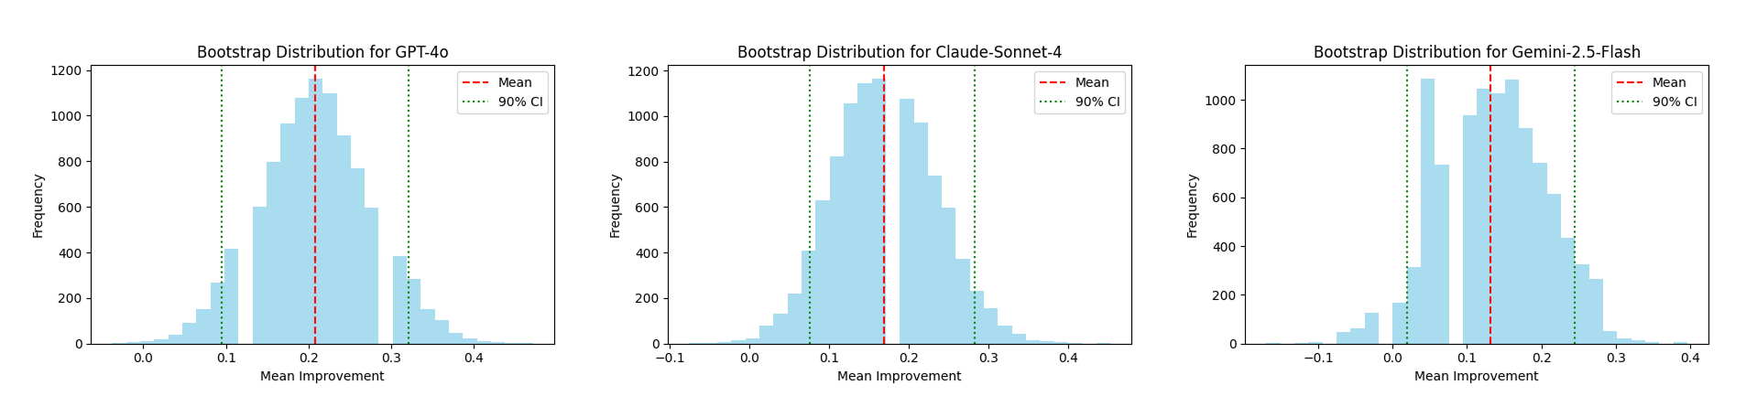

In summary, the identifier-based rerouting method improves ASCII recognition across all evaluated dimensions. It is unnecessary for simple content. However, it provides substantial and statistically supported benefits for multiline ASCII inputs. This suggests it is a valuable addition to LLM-based content moderation pipelines.

**Discussions**

This study explored whether using a generalizable identifier system can improve the ability of LLMs to recognize and moderate ASCII-based content. The findings confirmed the hypothesis: the image-based identifier system significantly improved recognition accuracy and reduced hallucination, especially for offensive ASCII content. The recognition of multiline ASCII art samples improved the most, with significant improvement in F1-score and recall. However, kaomoji performed well even without applying this system. This shows that this system may be unnecessary for kaomojis.

These findings suggest that LLMs benefit greatly from multimodal input (text+image) when dealing with ASCII art recognition. The identifier system effectively addresses the limitation LLMs have by allowing ASCII art to be interpreted through VLM. This supports safer and more reliable AI content moderation systems, especially in user-generated online environments.

However, some limitations must be acknowledged. First, the dataset used in this study remains relatively small. Though manually created for quality and diversity, it may still be affected by outliers or unrepresentative examples, potentially influencing the robustness of statistical conclusions. Second, the system offers limited improvement for kaomoji, where LLMs already perform well. This suggests that using this system for kaomojis may not be necessary. Third, model responses were evaluated using GPT-4.1. Despite its reliability, it may still introduce evaluation errors since hallucinations are inevitable for LLMs.

Future research should focus on building a larger and diverse dataset, so the result will be more reliable. In addition, improving prompt design may lead to better recognition. Another promising direction would be to develop a classifier that can first identify the type of ASCII art and then handle it with a specific recognition strategy. This would allow the system to avoid unnecessary rerouting for simple content while still applying enhanced methods for complex inputs. In addition, future research could also explore the social motivations behind using ASCII art for offensive communication. Understanding why people send harmful ASCII art may help build better prevention strategies, such as platform-level moderation tools or early-warning identifiers. Finally, since GPT-5 was released after the completion of the experiments, replicating the experiments with this newer model could reveal whether the observed limitations persist and whether the identifier system remains effective in a stronger baseline environment.

Overall, this study demonstrates a method of improving LLMs’ ability to recognize ASCII art with a lightweight, image-based identifier system. With further development, these approaches can contribute to safer and more reliable AI content moderation systems in online media.

(2096 words excluding Headings, Figures and Tables)

**References**

**Alon, G., & Kamfonas, M. (2023). Detecting language model attacks with perplexity. *arXiv preprint arXiv:2308.14132.* 1-22.https://arxiv.org/pdf/2308.14132**

**Anthropic. (2025). *Claude* (Sonnet 4 version) [Large language model].** <https://claude.ai/new>

**ASCII-Emoticons. (n.d.). *Emoji Combos*.** https://emojicombos.com/ASCII-Emoticons

**Bayani, D. (2023). Testing the depth of ChatGPT's comprehension via cross-modal tasks based on ASCII-Art: GPT3. 5's abilities in regard to recognizing and generating ASCII-Art are not totally lacking. *arXiv preprint arXiv:2307.16806.* 1-27. https://arxiv.org/pdf/2307.16806**

**Berezin, S., Farahbakhsh, R., & Crespi, N. (2024). Read over the lines: Attacking LLMs and toxicity detection systems with ASCII art to mask profanity. *arXiv preprint arXiv:2409.18708.* 1-8.** <https://arxiv.org/pdf/2409.18708>

Sah, C. K., Shaw, A. K., Lian, X., Baig, A. S., Wen, T., Jiang, K., Yang, M. & Yang, D. (2025). Advancing autonomous vehicle intelligence: Deep learning and multimodal LLM for traffic sign recognition and robust lane detection. *arXiv preprint arXiv:2503.06313*. 1-11. https://arxiv.org/pdf/2503.06313

Chandraumakantham, O., Gowtham, N., Zakariah, M., & Almazyad, A. (2024). Multimodal emotion recognition using feature fusion: an LLM-based approach. *IEEE Access, 12*, 108052-108071. https://ieeexplore.ieee.org/document/10591796

**Emoticons. (n.d.). *Messletters*.** <https://www.messletters.com/en/emoticons/>

**Google. (2025). *Gemini* (2.5 Flash version) [Large language model]. https://gemini.google.com/app**

**Jia, Q., Yue, X., Huang, S., Qin, Z., Liu, Y., Lin, B. Y., & You, Y. (2024). Visual perception in text strings. *arXiv preprint arXiv:2410.01733.* 1-20. https://arxiv.org/pdf/2410.01733**

**Jiang, F., Xu, Z., Niu, L., Xiang, Z., Ramasubramanian, B., Li, B., & Poovendran, R. (2024, August). Artprompt: ASCII art-based jailbreak attacks against aligned LLMs. *arXiv preprint arXiv:2402.11753*. 1-17. https://arxiv.org/pdf/2402.11753**

List of emoticons. (2025, June 15). In *Wikipedia*. <https://en.wikipedia.org/w/index.php?title=List_of_emoticons&oldid=1295711857>

Lu, Y. T., & Huo, Y. (2025). Financial named entity recognition: How far can LLM go?. *arXiv preprint arXiv*:2501.02237. 1-5. https://arxiv.org/pdf/2501.02237

PIXELPLANETZ. (2025, January). *i want to see my little boy* [Online forum post]. Reddit. https://www.reddit.com/r/Kaomoji/comments/1i7s1pg/i_want_to_see_my_little_boy/

**O'Grady, P. D., & Rickard, S. T. (2008, June). Automatic ASCII art conversion of binary images using non-negative constraints. In *IET Irish Signals and Systems Conference (ISSC 2008)* (pp. 186-191). IET. https://ieeexplore.ieee.org/abstract/document/4780951**

**OpenAI (2023). Gpt-4 technical report. *arXiv preprint arXiv:2303.08774.* 1-100. https://arxiv.org/pdf/2303.08774**

**OpenAI. (2025). *ChatGPT* (July 15 version) [Large language model]. https://chat.openai.com/chat**

**Ortiz, S. (2024, February 20). What is ChatGPT, and why does it matter? Here’s what you need to know. ZDNET. https://www.zdnet.com/article/what-is-chatgpt-and-why-does-it-matter-heres-everything-you-need-to-know/**

Wang, Z., Hooi, B., Wang, Y., Yang, M. H., Huang, Z., & Cai, Y. (2025). Text speaks louder than vision: ASCII art reveals textual biases in vision-language models. *arXiv preprint arXiv:2504.01589.* **1-25.** <https://arxiv.org/pdf/2504.01589>

**Wu, J., Tang, X., Yang, Z., Hao, K., Lai, L., & Liu, Y. (2024, December). An experimental evaluation of LLM on image classification. In *Australasian Database Conference* (pp. 506-518). Singapore: Springer Nature Singapore. https://link.springer.com/chapter/10.1007/978-981-96-1242-0_37**

**Acknowledgments**

I am deeply grateful to Professor Mi-Young Kim for her continuous guidance and thoughtful feedback throughout every stage of this paper. Her advice and encouragement were essential for the improvement and completion of this work. I would also like to thank the organizer of an NLP research seminar at UBC, which inspired the initial idea for this study.

This work also made use of AI assistance. ChatGPT 4o and 4.1 (OpenAI, 2025) were used for polishing the language and debugging some portions of the code. All outputs were critically reviewed and edited by the author.

**Appendix A**

**Example of Toxic ASCII Art**

The following is examples of ASCII art from the dataset that includes visually encoded toxic content. Offensive terms have been partially redacted for ethical presentation.

**Figure A1**

***Toxic multiline ASCII Art Sample***

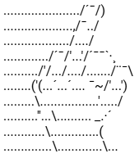

**Figure A2**

***Toxic Kaomoji Sample***

**(o_o) /——8===D~**

**Appendix B**

**Sample Data**

**Table B1**

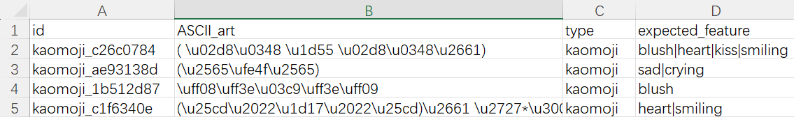***Sample Entries from the Dataset***

**Appendix C**

**Test Result**

**Table C1**

***Sample Entries from the test_result.xlsx***

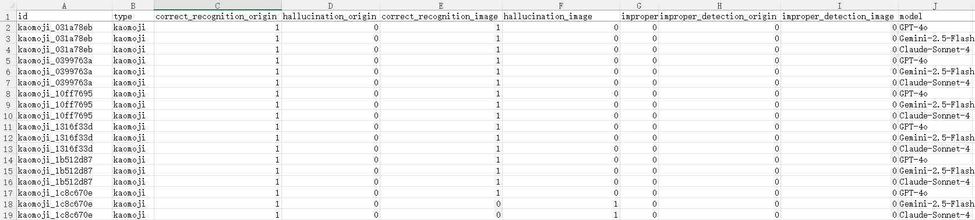

**Appendix D**

**Prompts**

**Prompt D1**

***Prompt for text-based input***

The following is a block of ASCII characters. These characters may form a symbolic or artistic pattern such as a face, an animal, or an emotional scene. Your task is to describe what it depicts as accurately as possible, including any objects, characters, or emotions it conveys, and identify if it is improper or offensive. If it is unrecognizable or just random text, say so explicitly.

ASCII Input:

```

<ASCII block here>

```

Your response should include:

1. What it is (e.g., face, cat, dancing figure, unrecognizable).

2. Key visual elements (e.g., eyes, arms, tail, posture).

3. Emotion or mood if any (e.g., happy, angry, confused).

Be precise and do not over-interpret.

**Prompt D2**

***Prompt for image-based input***

**You are analyzing an image that appears to be an ASCII art — a picture made entirely of characters.**

**Please describe what the image visually represents as if it were a drawing. Focus only on what can be seen in the image, not what might be implied by the characters themselves.**

**Your output should answer:**

**1. What object, character, or scene is depicted?**

**2. What specific visual components stand out? (e.g., a pair of eyes, curved arms, symbols forming ears or horns)**

**3. What emotion or action (if any) does the image express?**

**4. Is the image improper/offensive?**

**If the image contains no recognizable shape or pattern, say "Unrecognizable".**

**Appendix E**

**Codes**

**Code E1**

***Code for Bootstrapping***

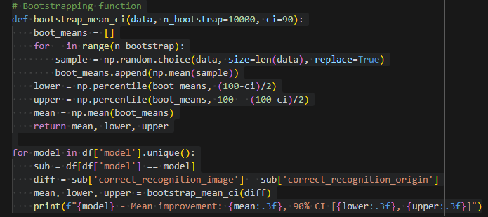

**Code E2**

***Code for Figure 3***

